**Autonomous robot with arm for warehouse application**

**Submitted**

**By**

**SUHAS S           BU21EECE0200034**

**PRAJWAL S     BU21EECE0200035**

**NAVATEJ M B  BU21EECE0200037**

**Under the Guidance of**

**Prithvi Sekhar Pagala, Head of Dept EECE**

**(Duration: 01/July/2024 to 05/Nov/2024)**



**Department of Electrical,Electronics and Communication Engineering**

**GITAM School of Technology**

**GITAM**

**(DEEMED TO BE UNIVERSITY)**

**(Estd. u/s 3 of the UGC act 1956)**

**NH 207, Nagadenehalli, Doddaballapur taluk, Bengaluru-561203 Karnataka, INDIA.**

**DECLARATION**

**I/We declare that the project work contained in this report is original and it has been done by me under the guidance of my project guide.**

**Name: SUHAS S**

**PRAJWAL S**

**NAVATEJ M B**

**Date: Signature of the Student**

**Department of Electrical,Electronics and Communication Engineering**

**GITAM School of Technology, Bengaluru-561203**



**CERTIFICATE**

**This is to certify that SUHAS S, PRAJWAL S, NAVATEJ MB bearing BU21EECE0200034, BU21EECE0200035, BU21EECE0200037 has satisfactorily completed Mini Project Entitled in partial fulfillment of the requirements as prescribed by University for VIIth semester, Bachelor of Technology in “Electrical, Electronics and Communication Engineering” and submitted this report during the academic year 2024-2025.**

**[Signature of the Guide] [Signature of HOD]**

**Table of contents**

**Chapter 1: Introduction 1**

1.1 Overview of the problem statement 1

1.2 Objectives and goals 1

**Chapter 2 : Literature Review 2**

**Chapter 3 : Strategic Analysis and Problem Definition 3**

3.1 SWOT Analysis 3

3.2 Project Plan - GANTT Chart 3

3.3 Refinement of problem statement 3

**Chapter 4 : Methodology 4**

4.1 Description of the approach 4

4.2 Tools and techniques utilized 4

4.3 Design considerations 4

**Chapter 5 : Implementation 5**

5.1 Description of how the project was executed 5

5.2 Challenges faced and solutions implemented 5

**Chapter 6:Results 6**

6.1 outcomes 6

6.2 Interpretation of results 6

6.3 Comparison with existing literature or technologies 6

**Chapter 7: Conclusion 7**

**Chapter 8 : Future Work 8**

Here write Suggestions for further research or development Potential improvements or extensions 8

**References 9**

# Chapter 1: Introduction

## Overview of the problem statement

In modern warehouses, the efficiency and accuracy of material handling are critical factors that directly impact operational costs and overall productivity. Traditional warehouse operations often rely heavily on manual labor for tasks such as picking, placing, stacking, and sorting products. While this approach can be effective, it is also prone to human error, fatigue, and inefficiencies, especially in environments that demand high throughput and precision

1. **Tiring, Repetitive Work:** Workers in warehouses often have to do the same tasks over and over again, like picking items from shelves, packing boxes, or stacking products. This can be exhausting and can lead to burnout.
2. **Human Error:** No matter how careful workers are, mistakes happen. Products might be placed in the wrong location, or the wrong items might be picked for an order, which leads to delays, returns, and unhappy customers.
3. **Variable Productivity:** People have good days and bad days. This means that the speed and accuracy of work can vary from one day to the next, making it hard to keep up with demand during busy times.
4. **Labor Shortages:** It can be difficult to find and keep enough workers to handle all the tasks in a warehouse, especially during peak seasons like holidays. This often leads to higher labor costs as businesses try to hire more temporary workers.
5. **Safety Risks:** Warehouse environments can be dangerous. Workers might need to lift heavy boxes, operate machinery, or navigate crowded spaces, all of which can lead to accidents and injuries.
6. **Difficulty in Scaling Up:** When business grows and more orders come in, it’s not easy to quickly scale up operations using just human workers. Adding more people takes time, costs more money, and might still not be enough to keep up with demand.

With the rise of online shopping and the need for faster deliveries, warehouses are under more pressure than ever to speed up operations while keeping costs down. Existing robotic solutions often struggle to handle a wide range of tasks or integrate smoothly with current warehouse setups.

To tackle these day-to-day challenges, an autonomous robot with an arm offers a practical solution. This type of robot can work around the clock, handling repetitive tasks without getting tired or making mistakes. It can also adapt to different products and warehouse layouts, making it a versatile tool for boosting efficiency and cutting down on errors

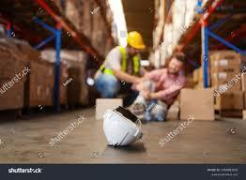

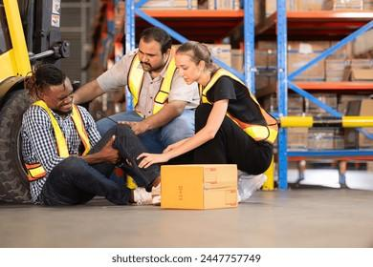

## Objectives and **goals**

## **(https://marobotic.com/projects/)**

The main objective of this project is to design, develop, and implement an autonomous robot equipped with a versatile robotic arm specifically tailored for warehouse operations. This robot aims to automate repetitive tasks, such as picking, placing, and stacking products, in order to improve overall warehouse efficiency, reduce operational costs, and minimize human errors. The system will be capable of integrating seamlessly with existing warehouse management systems, handling a wide range of products, and operating in various environmental conditions.

**Goals:**

1. **Increase Warehouse Efficiency:**
   * Develop a robot capable of operating continuously without the need for breaks or rest, leading to faster processing times and increased throughput.
   * Optimize the robot’s navigation and task execution to ensure smooth operations across various warehouse surfaces and layouts.
2. **Reduce Labor Costs and Reliance on Manual Labor:**
   * Automate tasks traditionally performed by human workers, such as picking and packing, reducing the need for large numbers of manual labourers.
   * Minimize the impact of labour shortages during peak periods and reduce the costs associated with hiring and training temporary staff.
3. **Enhance Accuracy and Reduce Errors:**
   * Incorporate advanced visual recognition systems, such as cameras and sensors, to improve the robot’s ability to accurately identify, pick, and place items.
   * Decrease the likelihood of mistakes in order fulfilment, leading to fewer returns, customer complaints, and lost revenue.
4. **Improve Safety in the Warehouse:**
   * Reduce the need for human workers to perform hazardous tasks, such as lifting heavy items or working in potentially dangerous environments.
   * Create a safer work environment by minimizing the risk of accidents caused by human error.
5. **Scalability and Flexibility:**
   * Design a modular system that can be easily scaled up or down based on warehouse needs, making it suitable for different sizes of operations.
   * Ensure the robot is adaptable to a wide range of product sizes, from small components to larger packages like pallets, making it a versatile solution for various industries.
6. **Seamless Integration with Existing Systems:**
   * Develop software and hardware that can be easily integrated with existing warehouse management systems, ensuring smooth communication and coordination between the robot and other technologies.
   * Implement QR code or barcode scanning capabilities to enhance inventory tracking and automation.
7. **Cost-Effectiveness:**
8. Ensure the robot is an affordable option for warehouses, offering a clear return on investment by reducing labour costs and increasing productivity.
   * Focus on a design that is easy to maintain and repair, minimizing downtime and keeping long-term operational costs low.
9. **Adaptability to Various Environmental Conditions:**
   * Design the robot to function reliably in different temperature ranges, humidity levels, and lighting conditions commonly found in warehouses

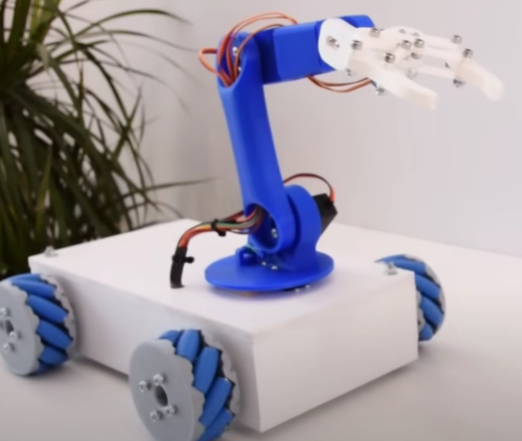

# Chapter 2: Literature Review

**1. Warehouse Automation and Robotics:**

Warehouse automation has emerged as a critical focus for improving efficiency in logistics and supply chain management. As companies shift towards e-commerce, the need for faster and more accurate order fulfilment has driven the adoption of robotic systems. Traditional warehouse operations rely heavily on manual labour for repetitive tasks, but with the rise of automation, robots are now taking over functions such as picking, packing, and transporting goods.

**Automated Guided Vehicles (AGVs)** were among the first robots introduced to warehouses. These robots follow pre-programmed paths and transport items between locations. While AGVs have improved efficiency, they lack the flexibility to adapt to dynamic environments, which limits their utility in complex warehouses.

Recent advances have introduced **Autonomous Mobile Robots (AMRs)**, which are more intelligent and can navigate independently using sensors and AI. AMRs offer greater versatility, as they can adjust to changing layouts and navigate around obstacles, making them more suitable for modern warehouse operations.

* **Source:** *International Federation of Robotics (IFR) Reports*  
  <https://ifr.org>
* **Source:** *McKinsey & Company: Automation in Logistics*  
  <https://www.mckinsey.com>

**2. Robotic Arms in Material Handling:**

Robotic arms have been widely used in manufacturing and industrial settings, but their application in warehouse automation is more recent. **Articulated robotic arms** offer a range of motion that enables them to perform complex tasks, such as picking items from shelves and placing them into packaging. These arms are designed to handle various items, from small, fragile products to heavy loads.

The development of advanced gripper technology and force sensors has enhanced the capabilities of robotic arms, enabling them to handle delicate items without causing damage. Researchers have also explored integrating robotic arms with mobile platforms, creating systems that can autonomously navigate a warehouse and perform tasks like picking and placing products in designated areas.

* **Source:** *IEEE Xplore Digital Library - Research Papers on Robotics*  
  <https://ieeexplore.ieee.org>
* **Source:** *Journal of Field Robotics*  
  <https://onlinelibrary.wiley.com/journal/15564967>

**3. Visual Recognition and AI in Robotics:**

The ability of robots to "see" and understand their environment is crucial for tasks such as identifying objects and navigating through a warehouse. **Computer vision**, a field of artificial intelligence, allows robots to process and interpret visual data. Through techniques like deep learning and **convolutional neural networks (CNNs)**, robots can now recognize products, scan QR codes, and determine how to grasp objects for transport.

One of the ongoing challenges in robotics is enabling robots to process visual data in real-time. Recent advancements in **edge computing** and **machine learning** have allowed robots to quickly interpret visual inputs and make decisions on the spot, increasing their effectiveness in dynamic environments.

* **Source:** *MIT Technology Review - AI in Robotics*  
  <https://www.technologyreview.com>
* **Source:** *OpenAI - Advances in AI and Machine Learning*  
  <https://openai.com/research>

**4. Challenges and Limitations of Current Robotic Solutions:**

While warehouse robotics have advanced significantly, several challenges remain. One of the most prominent barriers is **cost**. Implementing robotic systems in warehouses requires substantial upfront investment, which can be prohibitive for small to medium-sized operations. This has led to a focus on creating cost-effective robotic solutions that offer a faster return on investment.

**Adaptability and scalability** are also major concerns. Although robots are excellent at performing repetitive tasks, they struggle with environments that require constant adaptation to new layouts or tasks. Researchers are exploring ways to make robots more adaptable to varying conditions while ensuring they remain scalable for operations of different sizes.

Another area of focus is **human-robot collaboration**. Fully autonomous systems may not always be practical, especially in complex environments. Research suggests that a combination of human oversight and robotic automation can achieve better results, with robots handling repetitive tasks while humans manage more complex decision-making.

* **Source:** *Harvard Business Review - Robotics in Business*  
  <https://hbr.org>
* **Source:** *SpringerLink - Autonomous Robots Journal*  
  <https://link.springer.com/journal/10514>

**5. Future Trends in Warehouse Robotics:**

The future of warehouse robotics points toward increased intelligence, flexibility, and collaboration. **Collaborative robots (cobots)** are designed to work alongside human workers, assisting with tasks rather than replacing humans entirely. These robots improve safety and efficiency by taking on dangerous or repetitive tasks, while humans focus on higher-level activities.

As artificial intelligence continues to evolve, **AI-driven decision-making** will enable robots to perform tasks with greater autonomy and adaptability. Robots will be able to handle more complex operations without constant human intervention, making them even more valuable in warehouse settings.

Sustainability is another emerging trend in robotics. Researchers are exploring ways to make warehouse robots more energy-efficient and environmentally friendly. By optimizing movement paths and using energy-efficient components, future robots could help reduce the carbon footprint of warehouse operations.

* **Source:** *MIT Technology Review - Future of Robotics*  
  <https://www.technologyreview.com>
* **Source:** *SpringerLink - Autonomous Robots Journal*  
  <https://link.springer.com/journal/10514>

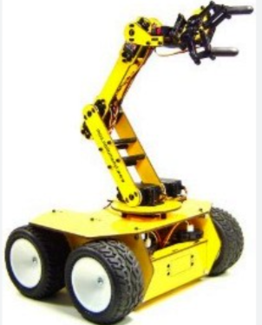

# Chapter 3: Strategic Analysis and Problem Definition

Order picking is one of the costliest tasks performed within an operation—not because it requires a high level of training or skill (it can), but because it is extremely time-consuming. In fact, physically walking from location to location within a facility can account for up to [75% of the time](https://www.conveyco.com/blog/warehouse-automation-statistics/) associated with picking.

When it comes to complementing your pick operation with AMRs, you have many different options at your disposal. The most common include:

* AMRs used in order picking
* AMRs that act as a flexible sortation solution
* AMRs that increase inventory visibility

We explore each of these options below.

1. AMRs Used In Order Picking

There are many varieties of AMRs designed specifically to reduce travel time associated with picking. This is accomplished by reducing picker travel time by bringing product to the picker. AMRs can be used to increase the productivity of picking operations in several ways.

AMRs used in conventional picking

We define conventional picking as having SKUs stored in a stationary, forward pick area in some type of shelving or rack, where pickers move from storage location to storage location picking SKUs and placing them into discrete order containers on conveyor, carts or manually carry.

In zone picking, an AMR takes an order tote/bin to a shelving or rack location within a zone. A picker, working that zone, is then able to select inventory from the surrounding locations to complete the order. Augmented vision, RF, paper pick lists or pick-to-light may be used to direct the picker. Once the order is complete the AMR will retrieve the tote and bring it to the next zone for further picking, or to a packing station for final shipping. This process is repeated with multiple AMRs operating and transporting to many zones. The end result is that a worker is able to spend more time actually picking orders, and less wasted time walking and searching.

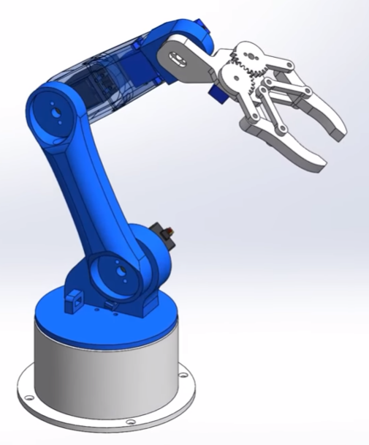

**AMRs used in Goods-to-Person Picking**

Goods-to-Person picking involves storing multiple SKUs in sections of shelving, rack or bins. The AMRs are directed to retrieve a specific SKU found in the shelving. The bot manoeuvres under the shelving and lifts it off the ground. The AMR then moves via the shortest path to the designated pick station.

The pick stations are designed to have a queue of AMRs with shelving on them ready to pick. The AMR moves into position and the pick-to-light directs the operator to make the correct pick and quantity. The operator is then directed to place the correct SKU and quantity into the open orders they have in their station. As they are putting the SKU into the proper open orders, the AMR leaves and a new one presents itself. This assures that the next pick is always waiting for the operator.

The WMS/WES systems manage the entire order fulfilment process. It tracks the location and quantity of each SKU stored, in order to coordinate and optimize the AMR tasks, this eliminates wasted operator walking, searching and dwell time increasing productivity by up to 450%.

Further productivity can be gained from this type of system by setting up packing stations for specific types of orders:

* **Single Line Orders:** Bring case quantity of one SKU to the station and fill multiple orders at one time.
* **VAS Orders:** Orders that are slow to pick and/or pack that require gift cards or special handling like fragile products.
* **Separate Ecommerce and Retail/Wholesale Stations:** These orders have different profiles that affect productivity. Having separate stations for each type of order will produce higher overall productivity and accuracy.

AMRs That Facilitate Picking in Other Ways

In addition to the varieties discussed above, there are other ways that AMRs can be used to facilitate the picking process.

For example, they can be used for real-time SKU replenishment. AMRs can be used to not only carry replenishment containers to the forward pick area, but also put the containers away automatically in rack, shelving, or carton flow rack. The host system knows when a SKU storage location is running low and can generate and deliver the required replenishment inventory.

In a fulfilment operation that uses a conveyor to transport order containers through picking, packing, and shipping, there can still be product or orders that are not suited to the conveyor system. The product can be fragile or the container too large to go on the conveyor system, or the operation may have 80% of the picking locations serviced by the conveyor system and 20% (slowest moving SKUs) stored and picked in an offline area. In these situations, AMRs can be used like flexible conveyor to transport the orders through picking and then delivered the completed orders directly to a specified packing or shipping station or area. If there are case pick orders where split case orders are fulfilled, AMRs can be used to handle pallets or cartons and eliminate the related travel labour.

**2. AMRs for Flexible Sortation**

Autonomous mobile robots can also play an important role in sortation. Different models come equipped with a variety of handling technologies. From conveyor roller to tilt trays and cross belt systems, AMRs are equipped for a wide range of sortation solutions including:

* High-speed parcel sortation
* Ecommerce order fulfilment
* Returns handling
* Short-term sortation

**High-speed AMR sortation** is easily achieved by utilizing a fleet of Tilt Sort-Bot tilt tray AMR models. These bots work on a mezzanine with chutes for location or order positions. Either people or robotic arms induct an item on the top of the Tilt Sort-Bot. The induction station camera above the bot reads the barcode and takes off via the shortest path to its destination chute. Once it comes upon its chute position, it stops parallel to it and tilts the item off the bot and down the chute. Items or parcels are collected in sacks, gaylords or containers. Once complete either an operator or AMR takes the completed order to shipping. Another AMR brings in an empty container to resume the sortation process.

## 3.1 SWOT Analysis

**Strengths:**

1. **Increased Efficiency:**
   * The robot can operate continuously, without breaks, leading to faster and more consistent warehouse operations. It automates repetitive tasks, such as picking, placing, and sorting, increasing overall productivity.
2. **Cost Reduction:**
   * By automating manual labour tasks, the system can reduce long-term labour costs. It also minimizes the need for temporary labour during peak times, which can be expensive and inefficient.
3. **Accuracy and Precision:**
   * The robotic arm, combined with advanced visual recognition and AI, ensures precise handling of products, reducing errors in order fulfilment. This leads to fewer returns and higher customer satisfaction.
4. **Adaptability:**
   * The system can handle a wide range of products, from small items to large packages, making it versatile across different industries. It can also operate in various environmental conditions, such as varying temperatures and lighting.
5. **Safety Improvements:**
   * By automating dangerous or physically demanding tasks, the robot reduces the risk of injury for human workers, leading to a safer workplace.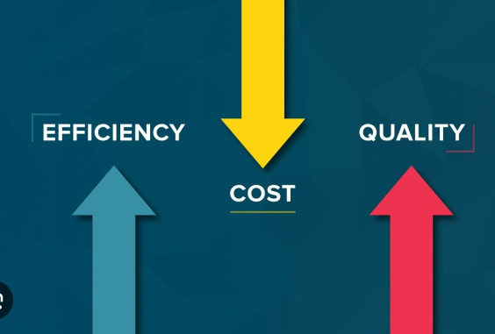

**Weaknesses:**

1. **High Initial Cost:**
   * The upfront investment for developing and deploying the robot can be significant, which may be a barrier for small and medium-sized warehouses. Additionally, maintenance and repairs can add to the costs.
2. **Complex Integration:**
   * Integrating the robot with existing warehouse management systems and infrastructure can be challenging. This requires careful planning and coordination to avoid disruptions in operations.
3. **Technical Limitations:**
   * Despite advancements in robotics and AI, the system may still struggle with unstructured environments where tasks vary significantly. The robot may not handle complex scenarios as well as a human worker can.
4. **Dependence on Technology:**
   * The robot’s effectiveness relies on the proper functioning of its hardware and software. Any malfunction or technical issue could lead to significant downtime, affecting productivity.

**Opportunities:**

1. **Market Demand for Automation:**
   * As e-commerce and logistics industries continue to grow, there is an increasing demand for automation in warehouses. The development of autonomous robots aligns with the trend toward faster and more efficient order fulfilment.
2. **Expansion into New Markets:**
   * The technology can be adapted for various industries beyond warehousing, such as manufacturing, healthcare, and retail, offering new business opportunities and applications.
3. **Collaboration with Other Technologies:**
   * Integrating the robot with emerging technologies, such as the Internet of Things (IoT) and big data analytics, can enhance its capabilities. For instance, using IoT sensors to monitor inventory levels and automate restocking.
4. **Sustainability Initiatives:**
   * There is a growing focus on sustainability in warehouse operations. The robot can contribute to sustainability efforts by reducing energy consumption, optimizing workflows, and minimizing waste.
5. **Customizable Solutions:**
   * Offering customizable features and scalability allows the robot to meet the specific needs of different businesses, making it an attractive option for a variety of warehouse environments.



**Threats:**

1. **Competition:**
   * The robotics market is competitive, with many companies developing similar solutions. New innovations and competitive pricing from other companies could threaten market share and profitability.
2. **Technological Obsolescence:**
   * Rapid advancements in technology could render the current design outdated. Continuous R&D investment is necessary to stay ahead of technological trends and customer expectations.
3. **Cybersecurity Risks:**
   * As the robot relies on interconnected systems, it is vulnerable to cybersecurity threats, such as hacking or data breaches, which could disrupt operations and compromise sensitive information.
4. **Regulatory and Compliance Issues:**
   * The use of robotics in the workplace may be subject to regulatory scrutiny, especially concerning worker safety, data protection, and environmental impact. Failure to comply with regulations could result in fines or operational restrictions.
5. **Economic Instability:**
   * Economic downturns or fluctuations could reduce the demand for warehouse automation as companies tighten their budgets and delay investment in new technologies



### 3.2 Project Plan - GANTT Chart



#### 

##### 3.3 Refinement of problem statement

An autonomous robot designed for warehouse applications. The robot has four wheels for stable mobility and an articulated robotic arm with a camera attached. The scene shows the robot navigating a modern warehouse with tall shelves and boxes, picking up a product package with a QR code from a shelf. The warehouse has bright lighting and an industrial feel, with various stacked items and a dynamic work environment. The robot is performing a precise picking and placing operation, showcasing its adaptability and integration into the warehouse setting. An autonomous robot designed for warehouse applications. The robot has four wheels for stable mobility and an articulated robotic arm with a camera attached. The scene shows the robot navigating a modern warehouse with tall shelves and boxes, picking up a product package with a QR code from a shelf. The warehouse has bright lighting and an industrial feel, with various stacked items and a dynamic work environment. The robot is performing a precise picking and placing operation, showcasing its adaptability and integration into the warehouse setting.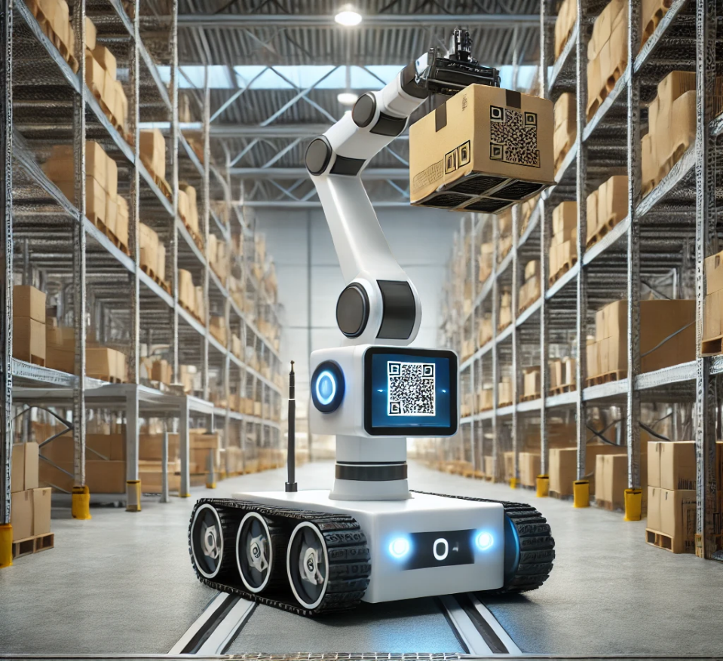

The increasing demand for faster and more efficient warehouse operations, driven by the rise of e-commerce and global logistics, has intensified the need for automation. Current manual labour-intensive processes are prone to human error, inefficiency, and safety risks, which can lead to delays, inaccuracies, and increased operational costs. While existing automated solutions like conveyor belts and Automated Guided Vehicles (AGVs) offer some relief, they often lack the flexibility and adaptability required for dynamic and complex warehouse environments.

This project addresses the problem of enhancing warehouse productivity by developing an autonomous mobile robot equipped with an articulated robotic arm. The robot will be capable of navigating through warehouse spaces, recognizing products using an integrated camera system, and performing material handling tasks, such as picking, placing, and stacking items, with high precision. The system aims to reduce reliance on manual labour, improve order fulfilment accuracy, minimize operational costs, and increase safety in the warehouse environment. Additionally, the solution seeks to be adaptable to different warehouse layouts and scalable to handle a wide range of products, from small components to larger packages.

This refinement of the problem statement emphasizes the need for a flexible, adaptable, and intelligent robotic system to meet the evolving challenges of modern warehouses.

# **Chapter 4 : Methodology**

## **4.1 Description of the approach**

For our project, we are using a mixed-methods approach that combines both quantitative and qualitative research to gain a comprehensive understanding of the problem.

**Research Design**: Our primary focus will be on collecting numerical data through structured surveys. Additionally, we will include open-ended questions to capture more detailed qualitative insights that numerical data alone might miss.



**Data Collection Methods**:

* **Surveys**: We will design a questionnaire that includes multiple-choice and scale-based questions, which will be distributed to approximately 100 participants. This will help us gather measurable data about their thoughts, behaviors, and experiences related to the issue.
* **Open-Ended Questions**: To allow for richer responses, we will incorporate a few open-ended questions where participants can share their views and experiences in their own words. This will help us identify themes and insights that may not be captured by closed questions.

**Sample Selection**: We will select participants from diverse backgrounds, ensuring a variety of demographics such as age, gender, and socioeconomic status. This diversity will help us capture a wide range of perspectives, making our findings more robust.

**Implementation**: Data collection will occur over a four-week period. We will use online survey platforms to distribute the questionnaires, making it easy for participants to respond at their convenience. We will also promote the survey through social media and community networks to reach our target audience effectively.

### **4.2 Tools and techniques utilized**

In our project, we used a combination of tools and methods to analyze the data we collected effectively.

**Analytical Tools**:

* **SPSS**: We used SPSS as our main tool for analyzing the numerical data from our surveys. With SPSS, we could perform important calculations like averages and percentages. This software helped us identify patterns and relationships in the data, allowing us to draw meaningful conclusions about our findings.
* **Google**: Throughout our research, we relied on Google to gather background information and find relevant data. This was essential for supporting our findings with existing literature and examples from other studies. It helped us broaden our understanding of the topic.



**Techniques**:

* **Descriptive Statistics**: We applied descriptive statistics to summarize our survey results and highlight key points. By looking at overall trends, we were able to see how many participants responded in specific ways, giving us a clear picture of the group’s opinions and behaviors.
* **Thematic Analysis**: For the open-ended questions in our survey, we carefully reviewed the responses to identify common themes. This involved looking for repeated ideas and sentiments among participants' answers, helping us understand their perspectives better.

Through this process, we worked collaboratively as a team, discussing our findings and analyzing the data together. Our faculty also supported us by guiding our research approach and helping us ensure we were on the right track. Overall, using SPSS, Google, and various analytical techniques allowed us to conduct a thorough examination of our data and present our findings in a clear and meaningful way.

#### **4.3 Design considerations**

### **Circuit Diagram**

In our project, we have prepared a circuit diagram that illustrates the setup we used for our experiment. This diagram provides a visual representation of the components and their connections, helping to clarify how our system operates.

**Components Used**:

1. **Robot Chassis**: The robot chassis serves as the foundation for mounting all the components. It provides stability and support, ensuring that everything is securely held in place during operation while allowing for mobility.
2. **L298N Motor Driver Controller**: This component is crucial for controlling the direction and speed of the DC motors. The L298N allows us to drive the motors forward, backward, and stop, making it an essential part of our circuit for motor control.
3. **12V DC Gear Motor**: We used a 12V DC gear motor to provide the necessary mechanical movement for our project. The gear mechanism increases torque while reducing speed, which is ideal for applications requiring power and control.
4. **12V 7Ah Lead Acid Battery**: This battery serves as the power source for the entire circuit. With a capacity of 7Ah, it ensures that the system has enough energy to operate the motors and other components for extended periods.
5. **ESP8266**: The ESP8266 is a Wi-Fi module that allows our project to connect to the internet. This component is essential for remote control and monitoring, enabling us to send and receive data over a wireless network.
6. **ESP32 Cam Module**: This module is equipped with a camera and allows us to capture images and stream video. It adds functionality for visual feedback and remote monitoring, making our project more interactive and user-friendly.

**Connections**: The diagram shows how each component is connected, including the paths for current flow. This layout is essential for understanding the circuit's operation. We followed standard practices to ensure that the connections are clear and that the circuit can be easily replicated.

**Purpose of the Circuit**: The circuit is designed to control the motors and capture images remotely. This functionality aligns with the objectives of our project, allowing us to gather data and test our hypotheses effectively.

**Testing and Results**: After assembling the circuit according to the diagram, we conducted several tests to verify its performance. The results indicated that the motors operated smoothly, and the ESP32 Cam module successfully captured and transmitted video. This confirmed that our circuit design was effective in achieving its intended purpose.

# 

# Chapter 5 : Implementation

## 5.1 Description of how the project was executed

### 5.2 Challenges faced and solutions implemented

# Chapter 6:Results

## 6.1 outcomes

### 6.2 Interpretation of results

### 

#### 6.3 Comparison with existing literature or technologies

# Chapter 7: Conclusion

Here write Suggestions for further research or development and Potential improvements or extensions

# 

# Chapter 8 : Future Work

#### Here write Suggestions for further research or development Potential improvements or extensions

#### 

# References